**FTP in JMeter:**

Test plan-right click-add-thread-thread group

Thread group-right click-FTP request.

Thread group-right click-add-listener-view result tree.

Take the file from the file zilla ,give path for the file to store in local machine.

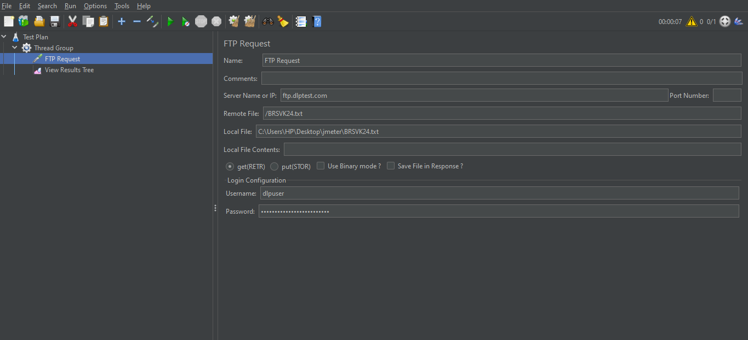

The result for above will show below and the we can see that the file is stored in the path which we provided.

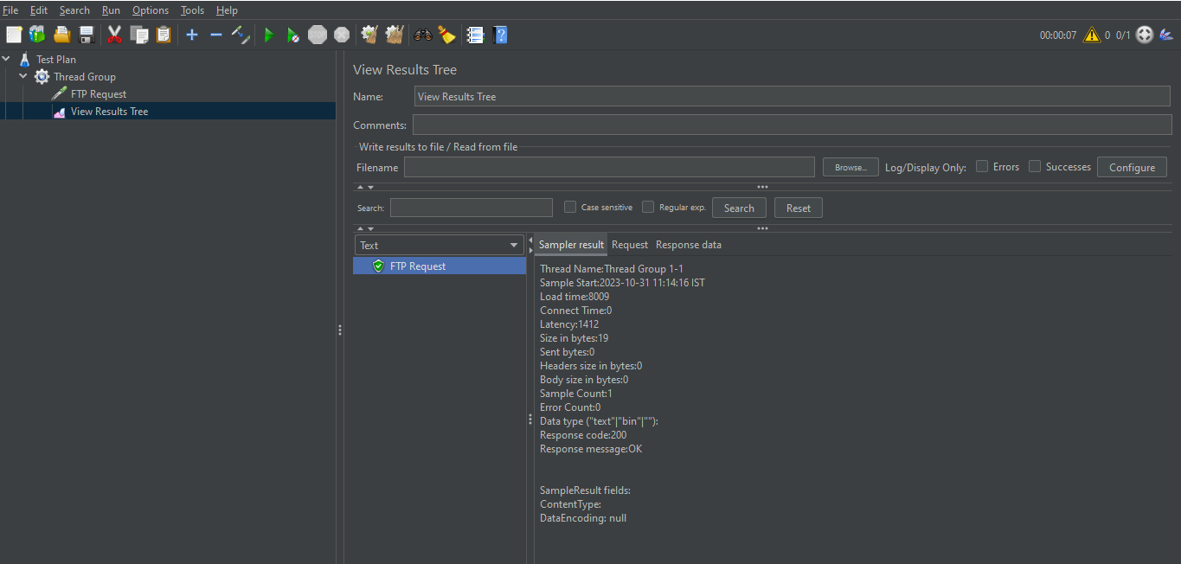

We can see the file taken from the file zilla will show in the local folder.

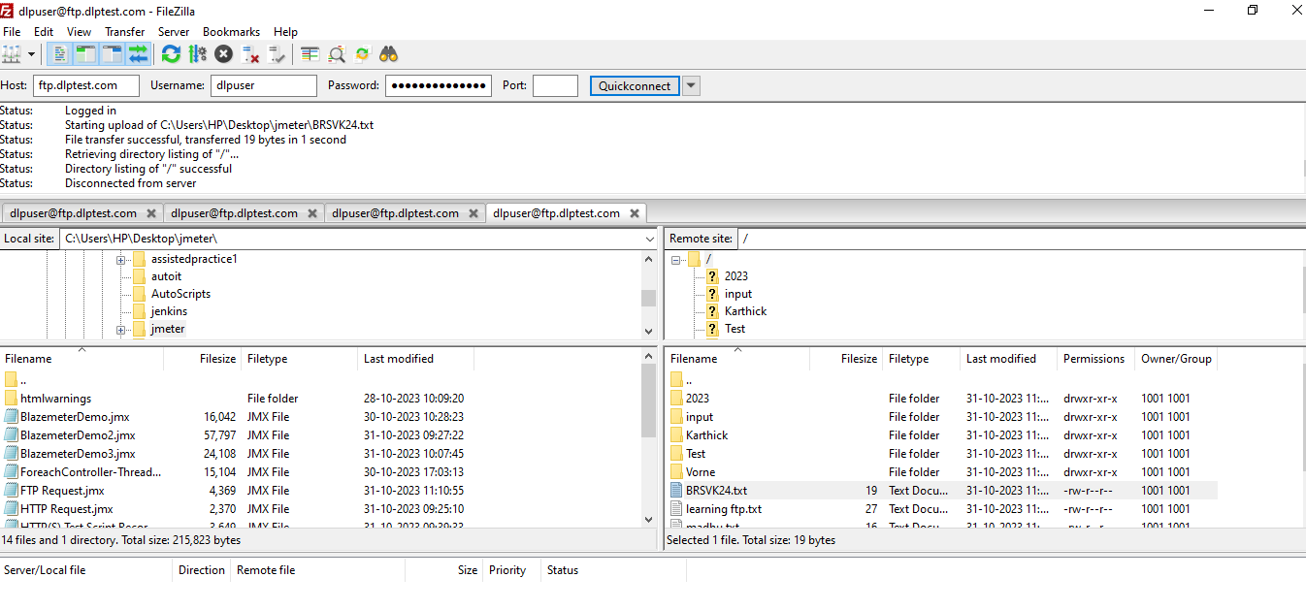

The above is the file zilla which we can transfer and download the files. The files we are taking must not be empty its need to be content in that.